**Bloomer Chamber of Commerce Newsletter**

**To register a unit in the parade, call 715-568-3339.**

**Sponsored by:**

**The Bloomer Chamber of Commerce**

**June 2025**

**2025 Parade Route**

The parade will begin at the corner of North Industrial and Vine Street. It will then travel on 9th Ave. past the North Park, up 9th Ave. past the fairgrounds and turn left at the corner of Priddy and 9th. It will then travel on Priddy St. to 4th Ave. where it will turn left onto 4th Ave. to the corner of 4th and Riggs Street. It will then turn right and travel to Catalytic Combustion where it will end at Riggs and North Industrial.

This is the same route as in 2024.

**August 10th, 2025**

**12:30 PM**

**Bloomer Community Parade**

**Help support your Local Chamber Members  
Purchase Chamber Checks!  
  
When you are looking for the perfect gift for family members, birthdays, employee’s or just any reason that you may need a gift and would like to show your support of our local Chamber Businesses. Purchase Bloomer Chamber Gift Checks!  
  
Gift checks can be purchased for any dollar amount and can be used at any Chamber Member Business.  
  
To order checks, call 715-568-3339 or stop by the office.  
You can also order online at** [**www.bloomerchamber.com**](http://www.bloomerchamber.com)**.**

**Merchant Booths Available**If you are interested in a Booth in one of the   
merchant buildings at this year’s Bloomer Community Fair, please call 715-568-3339.  
Booth sizes are  
 Single --- 8 x 8 $100.00  
 Double – 8 x 16 $150.00  
 If you are interested in an outside space, please call and we discuss size and location.  
 **Fair add letters have been mailed  
Thank you for your support!**

**Bloomer Community Club**

If you have any questions regarding the fair or events at the fairgrounds, please give us a call at 715-568-3339/ 715-210-0111 or emailing us at bchamber@bloomer.net

**Appreciation Picnic**  
  
Thank you to all those businesses that donated prizes for raffles and came out and helped worked the event-your support is appreciated.  
  
Special Thanks to Shadicks Price Rite Foods for their *generosity.*

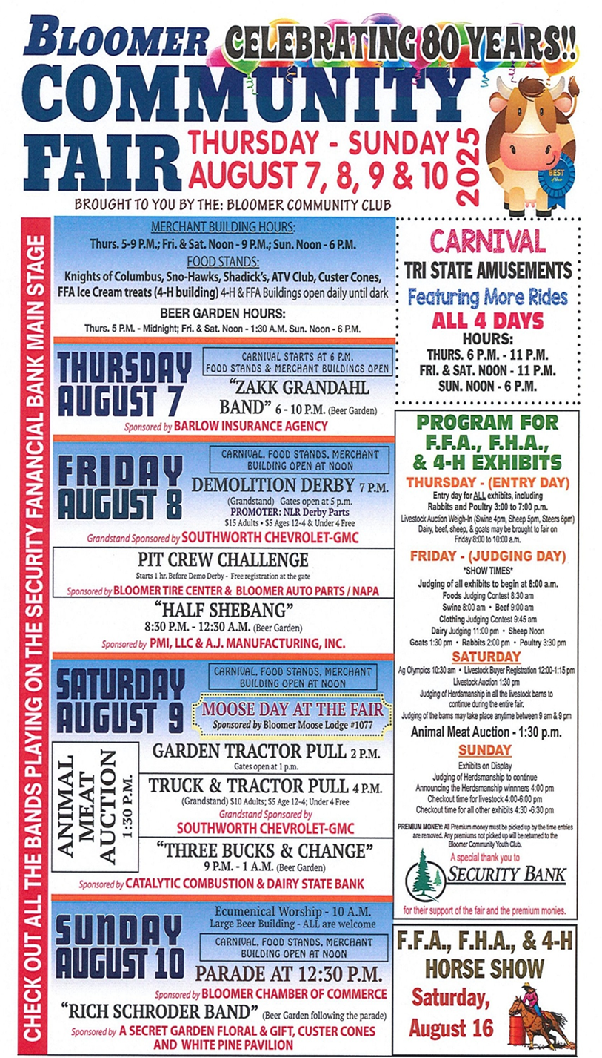

**Make sure Registration is in by Thursday, August 7th**

**Bloomer Chamber of Commerce**

**Annual Bloomer Community Parade**

The 80th Annual Bloomer Community Fair

will be held August 7th-10th, 2025 and

the Bloomer Community Club is planning for

a fun-filled weekend so be sure to attend!!!

The Annual Bloomer Community Days Parade

will be held on Sunday, August 10th, with line-up beginning at 10:00 a.m.

and the parade begins at 12:30 p.m.

If you would like to participate in the parade, please fill out the

registration below and return to the

Bloomer Chamber of Commerce at

PO Box 273, Bloomer, WI 54724.

**Please have this returned to the Chamber office by July 26, 2025. Thank You!!!**

PLEASE NOTE:

NO THROWING CANDY FROM VEHICLES!!!

NO WATER OF ANY SORT-- Spraying or Balloons

YOU MAY HAVE SOMEONE WALK BESIDE YOUR UNIT

AND DISTRIBUTE CANDY.   
**No Alcoholic Beverages of any type on the entry or in parade   
(if it is found that there is alcohol on the entry, you will not be allowed to participate)**

PLEASE DRIVE YOUR UNITS RESPONSIBLY.

THANK YOU.

WE HOPE TO SEE YOU IN BLOOMER ON August 10th, 2025.

________________________________________________________________________________________________

NAME: _________________________________________________________________________

ADDRESS: __________________________________________________

CONTACT NAME: __________________________ PHONE: ________________  
 Email Address: _______________________________________________________________________

TYPE OF UNIT (Circle one): Float Large/Semi Truck

Car/Pick-up Truck Music

Horses Walking (# of people) _____

**NOTE: This year’s parade route and line-up area is the same as last year. A map will be sent with your unit numbers when you register.**

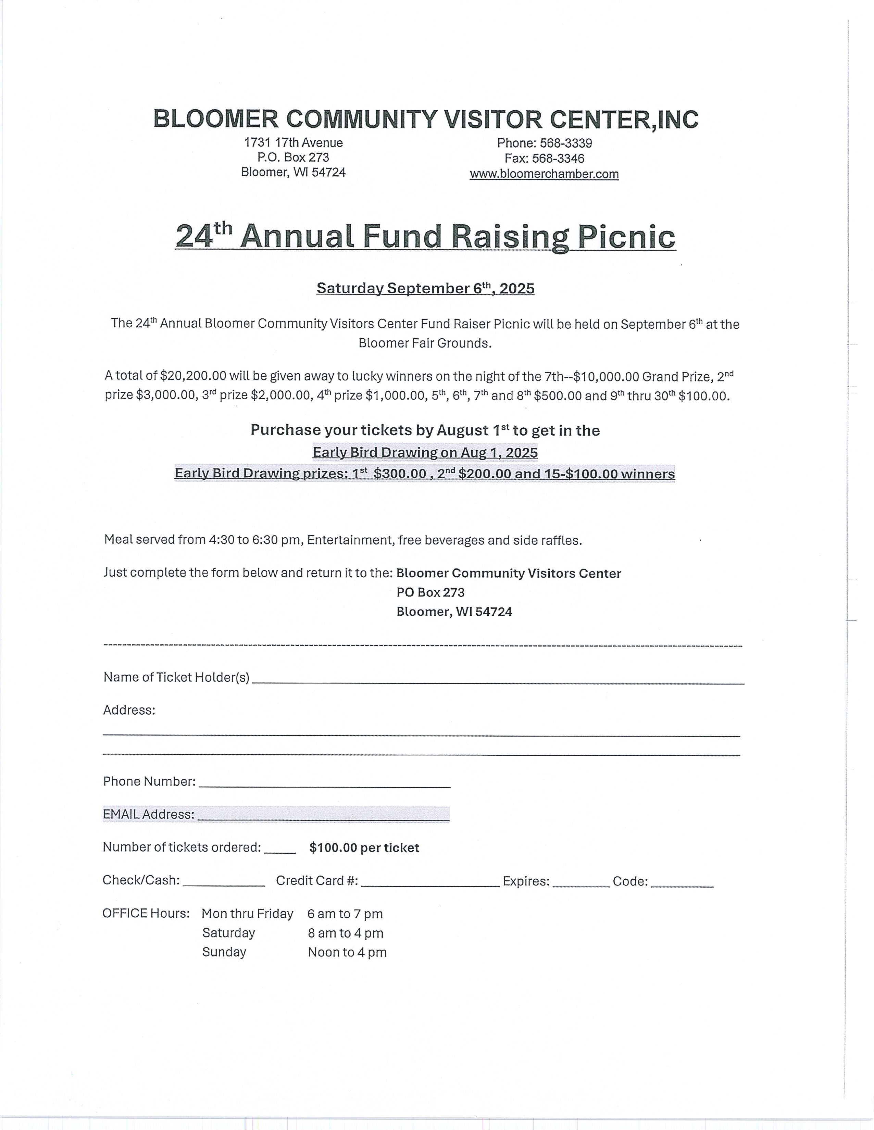

**Tech Times** Issue 00 Month Year

**Welcome NEW Members**

